|  |
| --- |
| Opensky_white_tag |

Technical Implement Document for Configuring Backups

National Transport Authority

CABS SQL Database Level Backups Plan

**Prepared by** Ajatha

[aindira@openskydata.com](mailto:aindira@openskydata.com)



# Purpose

Technical implementation document for CABS SQL Database Level Backups through SQL Server Maintenance wizard and SQL Server agent jobs.

# Scope of Document

This document outlines the main procedural steps to implement SQL Database Level Backups

## Storage options within existing NTA's infrastructure

**Prerequisite**:

* + NTA/Trilogy to provide a Network Share Drive with approx. 1 TB of free space to store backups.
  + Once the shared driver space is made available, create three different folders to store Full, differential and transaction log backups and then follow the process.

## CABS SQL Database Backups and Schedule:

* + **Full DB backup:** Occurs every week on Sunday at 4:00:00 PM
  + **Differential backups:** Occurs every day except Sunday

(Monday, Tuesday, Wednesday, Thursday, Friday, Saturday at 9:00:00 PM)

* + **Transaction logs:** Occurs every day every 2 hour(s) between 7:00:00 AM and 7:15:00 PM

## Retention Policy

The retention policy for these DB backups is 3 full backups - backup is generated older than 21 days will be automatically deleted by a cleanup job before executing the current backup.

## Configuring Database FULL backups using SQL Server Built-in Maintenance Task

The following steps explain how to set up an MS SQL maintenance plan for the CABS databases using the Maintenance Plan Wizard.

1. In **SQL Server Management Studio**, Go to **Management** and right-click **Maintenance Plans**, and then click Maintenance Plan Wizard.

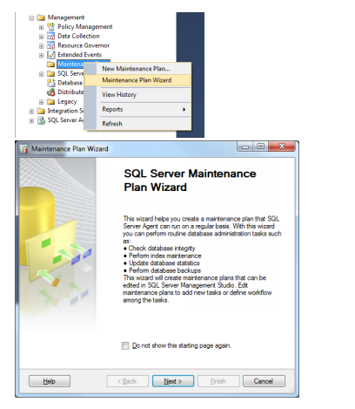

1. Click Next and give the Name: **MaintenancePlanFullBkp**

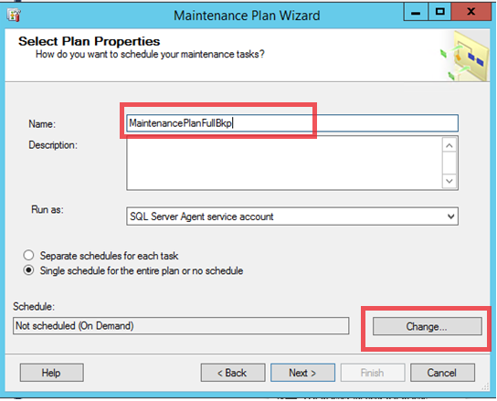

1. Click on **Change**... button under **Schedule**: and change as below schedule mentioned in **Red**.

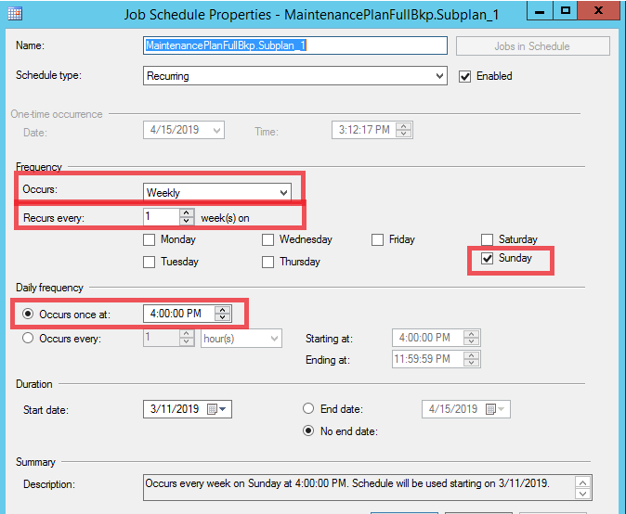

1. Click **Next and select the below three tasks**

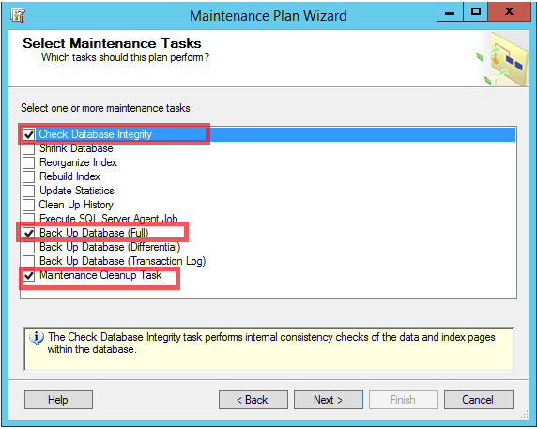

1. Rearrange the order in such a way that **Cleanup** task is in first place and second one for **Backup** and third as **Integrety** task

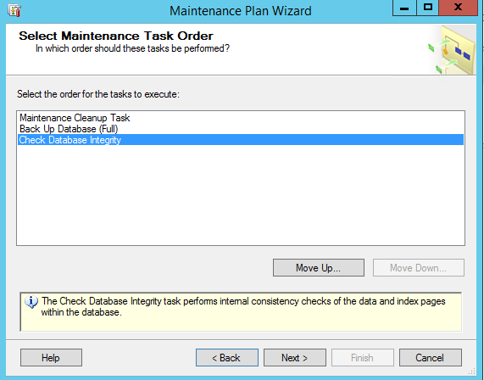

1. Click Next
2. **Define Maintenance Cleanup Task Parameters:**
3. Select the **dedicated folder** for **full backups** as mentioned in the **prerequisites**. And mention the retention (File age) as **21 days**

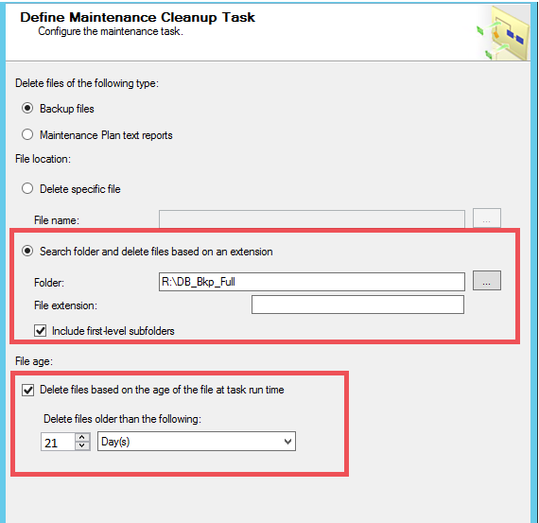

1. **Define Database Full Backup Task:**
2. Go to General tab
3. Select the two **red** highlighted options from the dropdown for **Database(s)** option

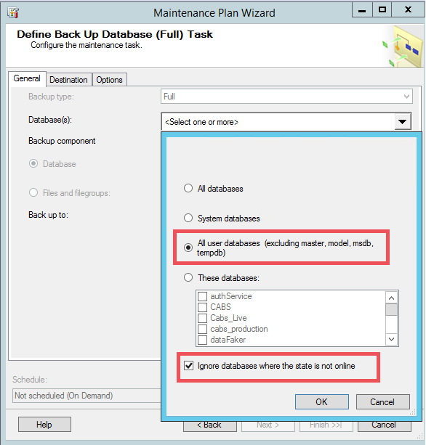

1. Click Ok
2. Select **Backup to** **Disk**
3. Go to Destination Tab
4. Go to highlighted options and mention the **destination path** for the full backups of user databases.
5. \*\*\* Select the **dedicated folder** for **full backups** as mentioned in the **prerequisites** to avoid confusion

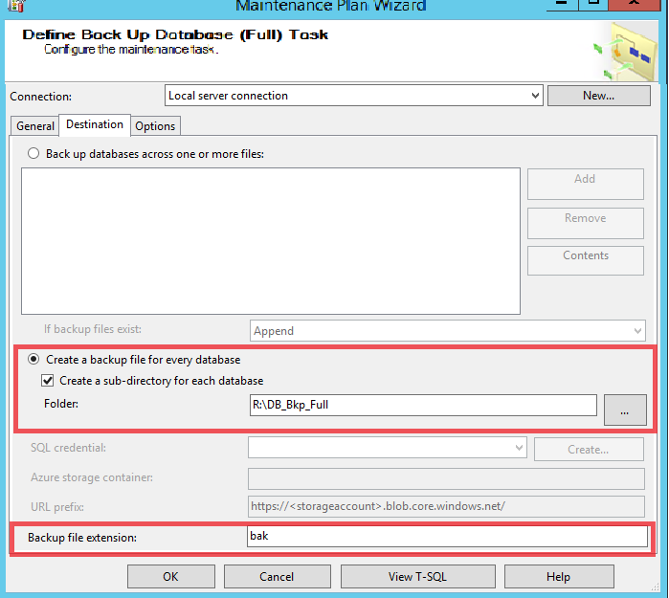

1. Go to **Options** tab and checkmark the below three options

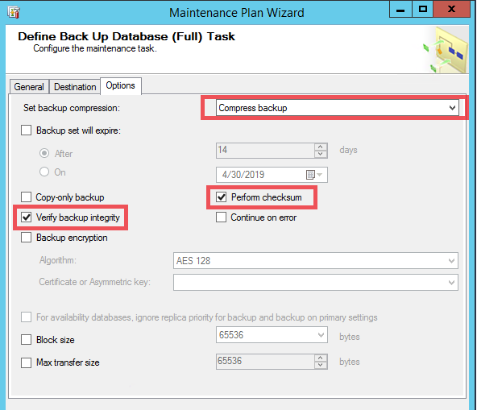

1. Next the wizard drives us to **Integrity check** task, please select the **user databases** from the drop down as mentioned below

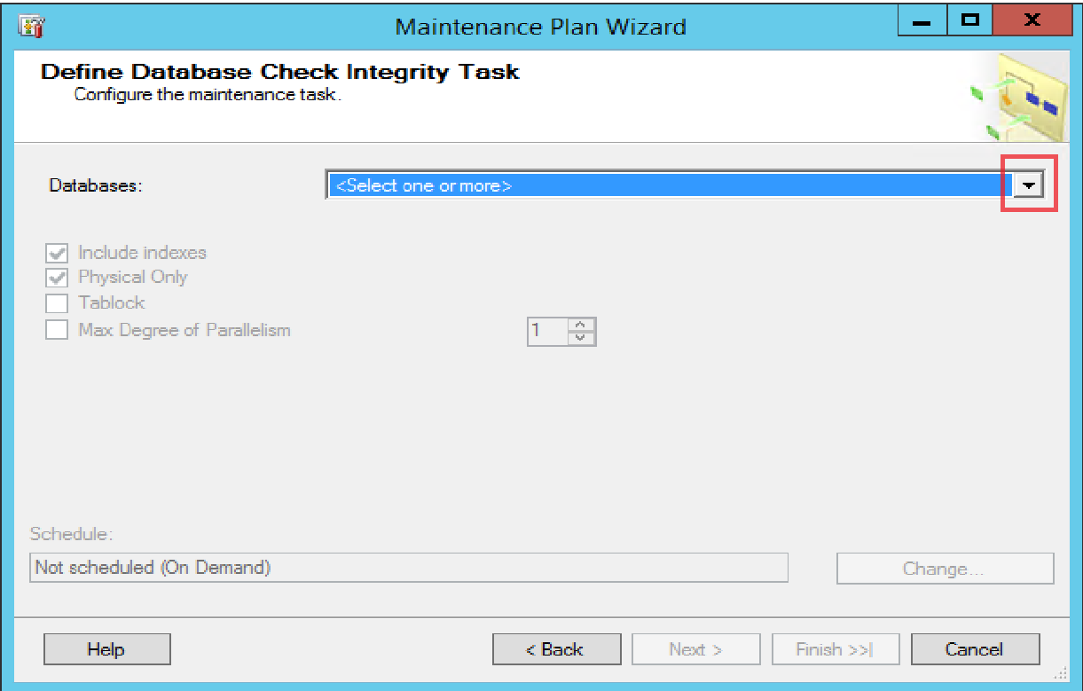

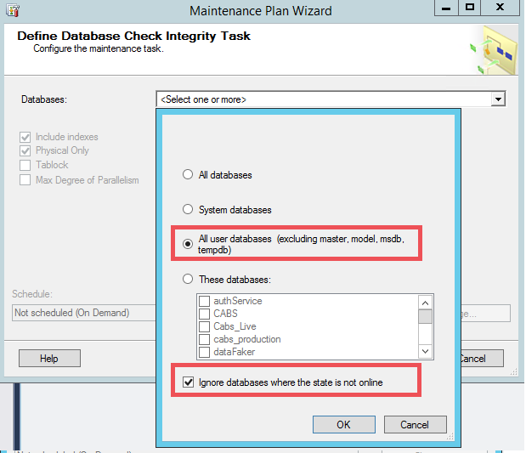

1. Select option **Physical Only** option for integrity check as mentioned below

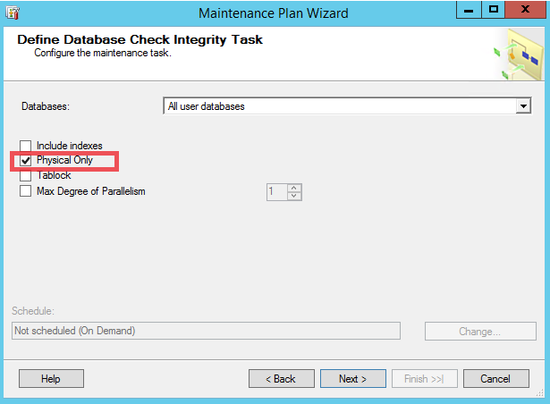

1. Click on Next and give valid Email address for sending a report of configuration setting.

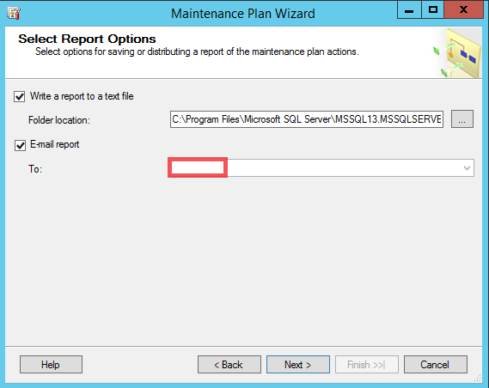

1. Click **Next** and **Finish**

## Configuring Database Differential backups using SQL Server Built-in Maintenance Task

1. In **SQL Server Management Studio**, Go to **Management** and right-click **Maintenance Plans**, and then click Maintenance Plan Wizard.

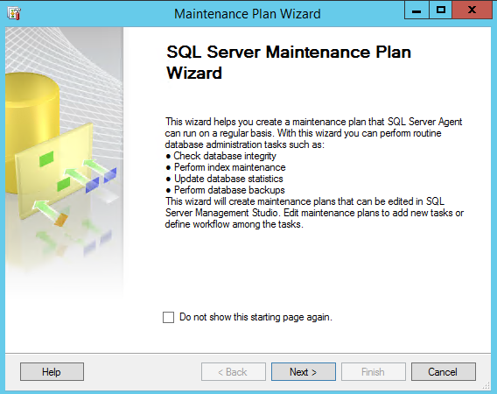

1. Give a meaning full name for Differential backup task and Click on **Change**... button under **Schedule**: and change as below schedule mentioned in **Red**.

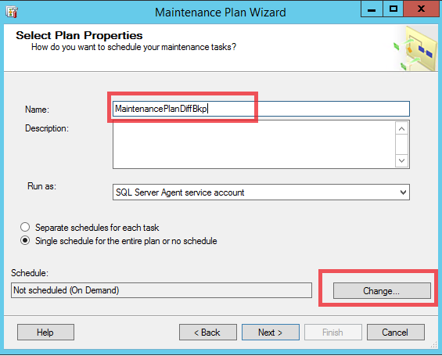

1. Select the below schedule:

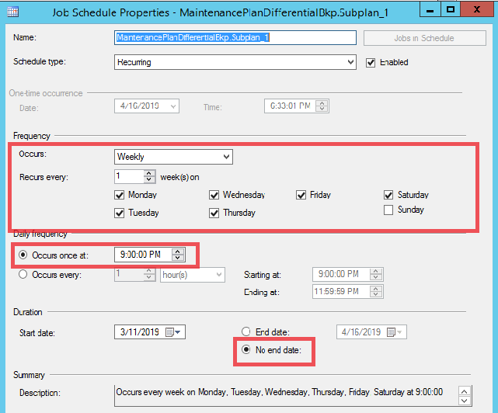

1. Select the below two tasks as mentioned in Red

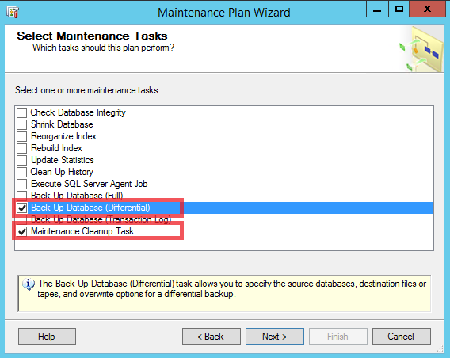

1. Rearrange the order in such a way that **Cleanup** task is in first place and second one for **Differential** **Backup**

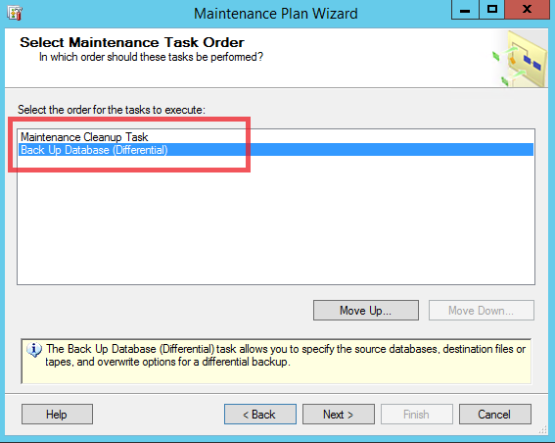

1. Select the **dedicated folder** for **Differential backups** as mentioned in the **prerequisites**. And mention the retention (File age) as 21 **days**

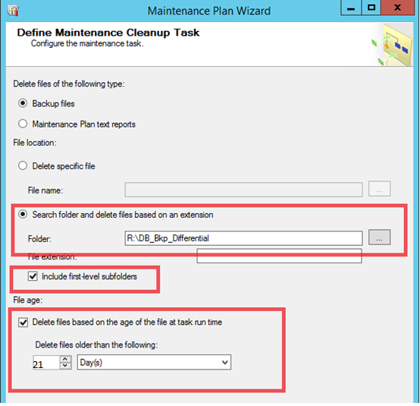

1. **Define Database Differential Backup Task:**
2. Go to General tab

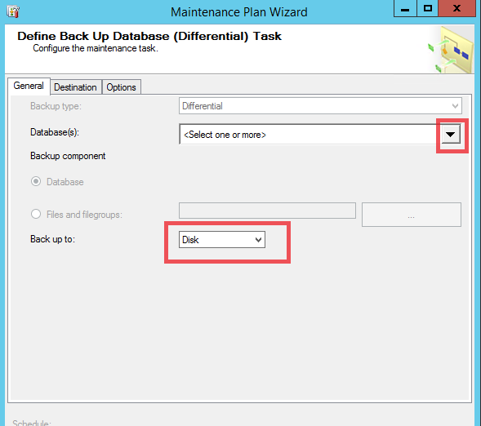

1. Select the two **red** highlighted options from the dropdown for **Database(s)** option

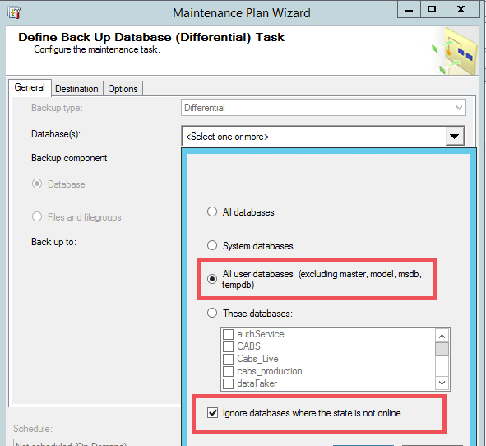

1. Go to **Destination** Tab
2. Go to highlighted options and mention the **destination path** for the Differential backups of user databases.
3. \*\*\* Select the **dedicated folder** for **Differential backups** as mentioned in the **prerequisites** to avoid confusion

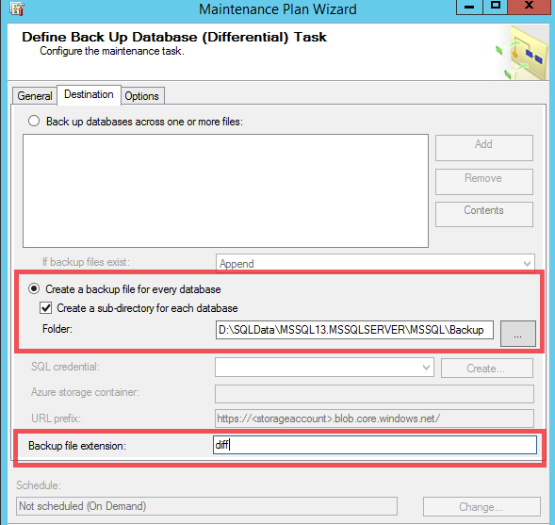

1. Go to **Options** tab and checkmark the below three options

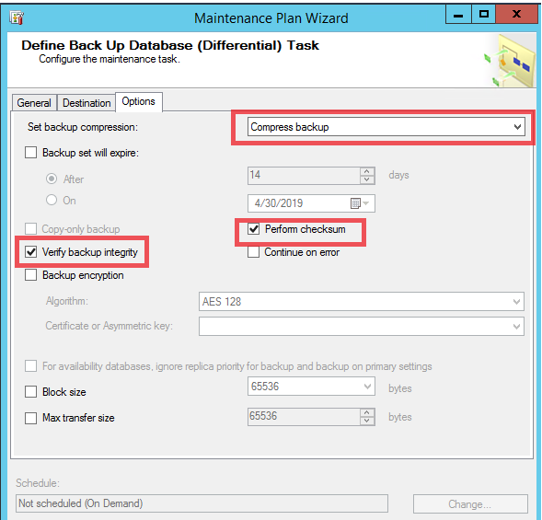

1. Click Next and **Finish**

## Configuring Database Transactional log backups using SQL Server Built-in Maintenance Task

1. In **SQL Server Management Studio**, Go to **Management** and right-click **Maintenance Plans**, and then click Maintenance Plan Wizard.

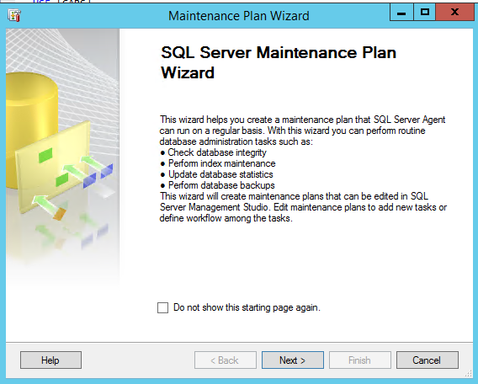

1. Give a meaning full name for Transactional log backup task and Click on **Change**... button under **Schedule**: and change as below schedule mentioned in **Red**.

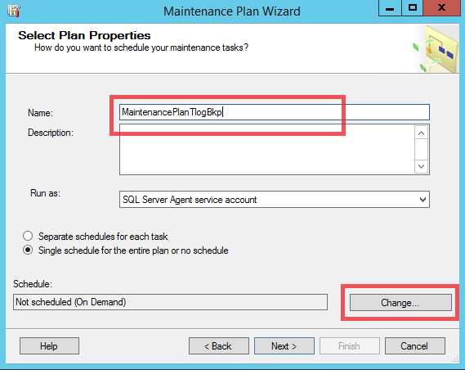

1. Select the below schedule:

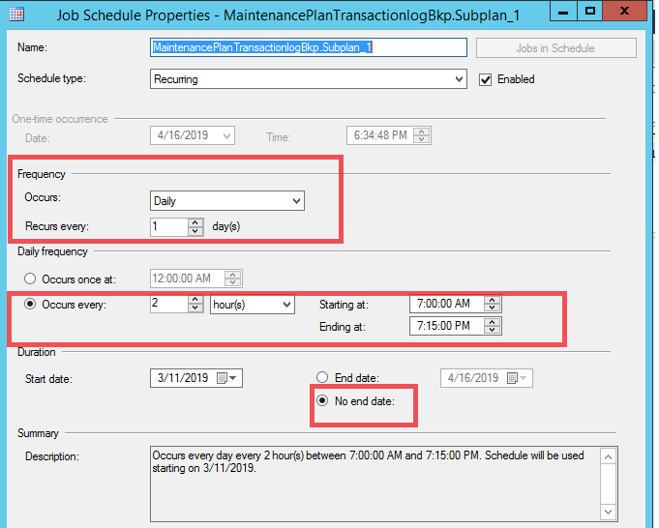

1. Click Next and select the below two options

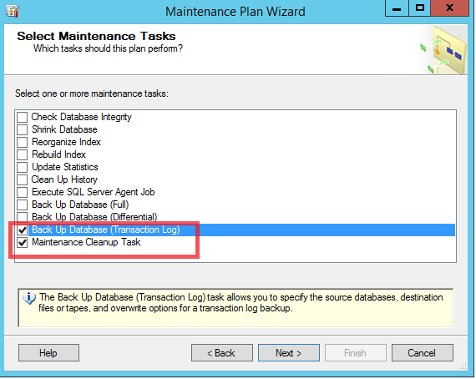

1. Rearrange the order in such a way that **Cleanup** task is in first place and second one for **Transaction log** **Backup**

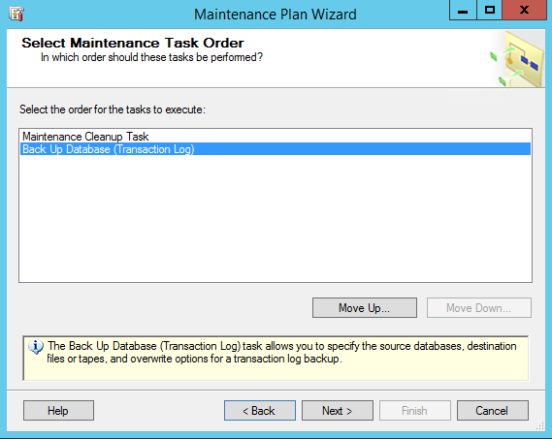

1. Select the **dedicated folder** for **Transaction Log backups** as mentioned in the **prerequisites**. And mention the retention (File age) as 21 **days**

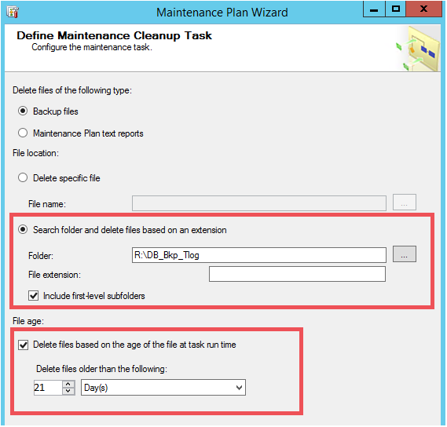

1. **Define Database Transaction Log Backup Task:**
2. Go to General tab

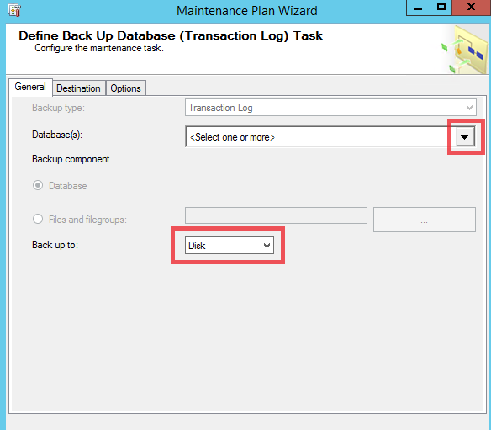

1. Select the two **red** highlighted options from the dropdown for **Database(s)** option

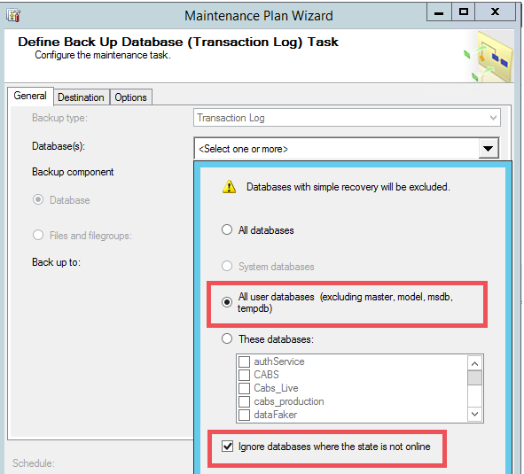

1. Go to **Destination** Tab
2. Go to highlighted options and mention the **destination path** for the Transaction Log backups of user databases.
3. \*\*\* Select the **dedicated folder** for **Transaction Log backups** as mentioned in the **prerequisites** to avoid confusion

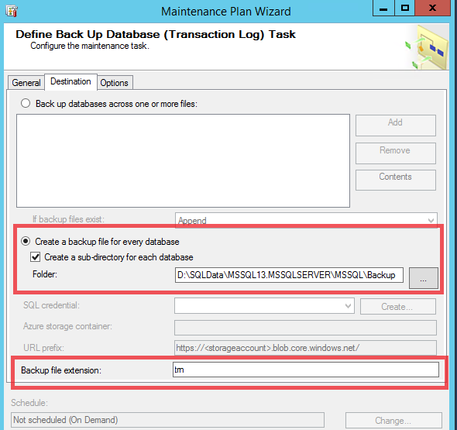

1. Go to **Options** tab and checkmark the below three options

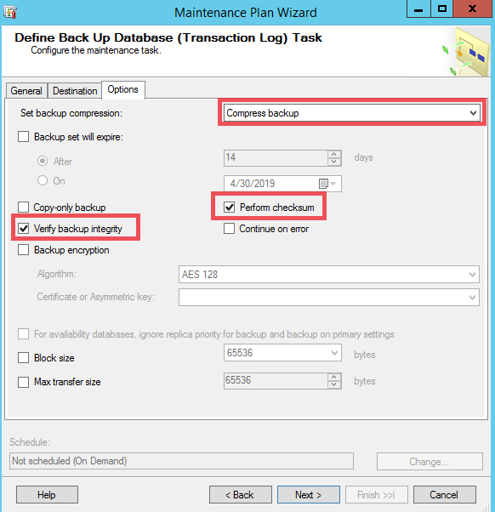

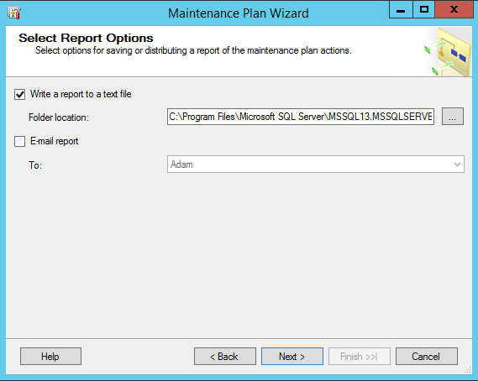

Click Next and **Finish**